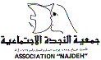
Annual Narrative report -2017

Name of the Organization: Association Najdeh
Reporting period: 1/1/2017- 31/12/2017

Association Najdeh’s Goals:
- To empower women and strengthen their rights in order to change dominant patriarchal and masculine values, structures and practices
- To strengthen the values and practices of comprehensive human rights for Palestinian refugees - women and men - in Lebanon.
- To contribute to securing holistic developmental support for the most vulnerable sectors of Palestinian society in Lebanon.

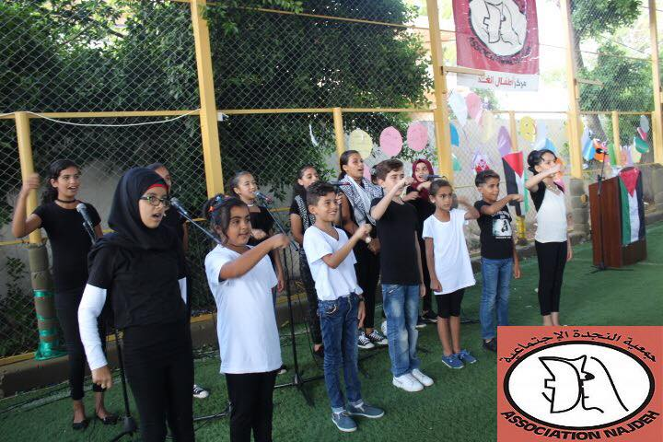

Introduction:
Lebanese government is still avoiding its commitments towards the improvement of Palestinian human rights and living conditions, it called upon the international community and UN agencies to hold their full responsibilities and continue the financial support to UNRWA. However, the US government had cut more than half of its planned funding to the United Nations agency for Palestinian refugees, it withheld $65m out of a $125m aid package earmarked for (UNRWA). Therefore, the current situation is leading to deprive the Palestinian refugees of the right to education, health, shelter and a dignified life. The five UNRWA operational countries are affected by this cut and that will generate further instability throughout the region. Meanwhile, Palestine refugees in Lebanon (PRL) face one of the worst socioeconomic conditions in the five UNRWA operational countries, so they will be deprived more of their basic human and civil rights, UNRWA will continue in cutting off its different main services and responsibilities as a result of its recent financial crisis. Palestinians considered all of these negative actionsas a backlash from the International community and Lebanon on their commitments toward right to return as well as the improvement of the human and socioeconomic situation. In addition, these were considered to end/cancel the refugees’ cause / right to return by pushing Palestinian refugees in Lebanon to choose immigration as the only possible solution for their sufferings.
The Palestinian refugees in Lebanon are deprived from basic human and civil rights; whereas, their economic, social and security conditions are getting worsened due to UNRWA’s cut off its basic services at health and education sectors, disregarding of Lebanese government for Palestinian refugees’ current situation and not including them in their announcements or agenda, and deriving of the attention of International communities to other emerging issues in different regions. The discriminatory laws against them hinder their ability to improve their living conditions and livelihoods. Decaying infrastructure, a dearth of recreational spaces, insufficient access to roads, deteriorated water and sewage treatment systems, contaminated water, and jerry-rigged electrical wires along with open drainage ditches paint a gloomy picture of camps where over 63 per cent of PRL reside.
Both Lebanese and Palestinian statistics bureaus and the Lebanese-Palestinian Dialogue Committee had carried out an official census of Palestinian refugees in Lebanon which found that 174,422 Palestinian refugees are living in the country - much lower than the previous estimate of 450,000. Palestinian figures and factions, local NGOs and other people had doubted the accuracy of this census where it didn’t reach all the Palestinian refugees who are living in Lebanese territory, then LPDC had stated that they may fall to reach around 40,000 to 50,000 Palestinian refugee, so the number of Palestinian refugees in Lebanon are around 220,000 population for 2017; whereas, UNRWA had stated in a survey in 2010 that number of Palestinian refugees living in Lebanon are around 270,000 to 280,000 population. As a result, Palestinian refugees are hoping that the Lebanese government may reconsider their situation and improve their living conditions by granting them their basic human rights, as the political figures and parties in Lebanon was enlarging the number of Palestinian refugees to reach half a million for political purposes.
In response to these news challenges; approaches followed were:
a- Collective and common actions, demands and appeals, including protests were organized against UNRWA policy, budget and service declining with the participation of local NGOs, political factions, etc. As a result, sectoral /programmatic committees were formed between UNRWA and Palestinian entities discussing alternative plans for UNRWA reduction of services. Consequently, UNRWA plans for some services /programmes were revised and updated based on demands.
b- Strengthening the coordination among local NGOs and raising their voice on the severe socio-economic conditions of PRL and PRS by organizing international conference on specific themes and demands. The findings of the conference and demands were disseminated over international community In Lebanon.
c- Statements by different NGOs, coalitions (including right to work coalition), political factions were submitted to the new Lebanese government on the human and social rights of Palestinians in Lebanon and the actions needed by the government.
Within the same context, the Lebanese authorities had been built a security wall on all over the boundaries of Ein El Helweh camp. Camp inhabitants, NGOs, and the Palestinian factions submitted demands and met with the Head of Parliament, head of ISF, army, etc to stop building the wall around the camp, since it is endangering the lives of the camp's population who are around 80,000 individuals, but it was built accusing this to security reasons.
It is to be clear that the only solution, even for a short term, for the Palestinian refugees in Lebanon is admitting their human and civil rights, which will not only affect the livings of the Palestinians in Lebanon, but also will accelerate and improve the Lebanese economy, and will decrease the negative effects resulting from unemployment after they start having a dignified life.
In addition, PRS currently residing in Lebanon face challenges in regularizing their legal status or residency. Since the arrival of PRS in the country, the General Security Office (GSO) has issued several circulars enabling PRS to renew the required residency permit. Most of these circulars have been valid for a period of one to three months, and many were issued with some intervals between them, during which time theoretically no renewal was possible. The renewal of residency was free of charge for the first year. During 2014 and part of 2015, the cost of renewing legal residency documents was US$ 200 per person per year for those who have exceeded one year of stay. It seems likely that many PRS did not approach the GSO for fear of arrest and deportation or due to the length and cost of the process.
Since 17 October 2015 several memos have been issued periodically allowing for a renewal of residency documents, free of charge. Some PRS with expired residency permits have been issued a departure order, though it is noted that these have not been enforced. UNRWA has been struggling to ensure adequate shelter, education, health care and other services to PRS, who now represent an approximate 20 per cent increase of beneficiaries in need of assistance in Lebanon.

Problem Addressed:
The targeted beneficiaries are significantly denied their basic human rights. They are subject to restrictions on their right to work and to earn a decent living; their rights to adequate shelter and dignified life, their free access of movement, while encountering gender based violence and discrimination. The key areas of concerns rose across all camps and gatherings included the followings:
- Increasing concerns violence in public and private spheres, including domestic violence and GBV that the consequences of Syria crisis and overcrowded places and displaced people have contributed to. Thus, different intervention approaches are needed for survivors including securing safe and protected place for GBV survivors and vulnerable cases.
- Discrimination at employability level and limited access to job opportunities due to the discriminatory Lebanese laws and working conditions of refugee women and men. Two approaches will be provided to changes the attitude and discriminatory practices related to the right to work for Palestinians, women access to job market and working discriminatory conditions and these are: service provision, mainly professional and vocational training courses that meet the market demands, and the mobilization and advocacy related to Palestinian refugee women’s socio-economic participation and free access to job opportunities for Palestinian refugees in Lebanon in general.
To encounter the above mentioned target groups and beneficiaries of this action, mainly women, will be acquired skills and acknowledge to cope the hard conditions and marginalization. Thus, they will be able to provide change to their status and to their community and/or contribute to change the stereotype of women, eliminate violence against them, etc.

This action will focus on the three linked components that will contribute to strengthen the rights of Palestinian women and men in Lebanon by empower women at economical, GBV and human rights perspectives to change dominant patriarchal and masculine values, structures and practices at local and national levels.
Through competency Development Palestinian refugee women in Lebanon will endow with skills to enter the labor market and thus will contribute to reduce the socio-economical gap and discrimination. It also will contribute to the development of the capacities of Palestinian women in camps and gatherings to participate in planning, evaluation and decision making. The raising awareness on Palestinian refugee rights, especially the right to work, as well as on violence and discrimination against women will strengthen the protection capacity and resilience of vulnerable groups especially women, meanwhile it will strengthen Palestinian refugee women’s public and political participation.
The above two components will be linked to the Mobilization, Advocacy and Lobbying at local and national levels aiming at reducing gender based violence and gender discrimination against Palestinian women in the camps and in Lebanon, while trying to improve the policies, practices and discriminatory laws violating the human rights of Palestinian refugee women and men in Lebanon.
The analysis back up references was different surveys (some mentioned above) and the latest socio-economic status of Palestinian refugee in Lebanon 2015 that have shown the following findings and figures:
- Palestine refugees in Lebanon (PRL) face one of the worst socioeconomic conditions in the region, and these have been deteriorating given the country’s weakening socioeconomic situation and the prolonged Syria crisis.
- A little short of two thirds of the PRL population is poor, a proportion that has not changed since 2010, and the discriminatory laws against them hinder their ability to improve their living conditions and livelihoods.
- Decaying infrastructure, a dearth of recreational spaces, insufficient access to roads, deteriorated water and sewage treatment systems, contaminated water, and jerry-rigged electrical wires along with open drainage ditches paint a gloomy picture of camps where over 63 per cent of PRL reside.
- As for the legal restrictions on PRS: In May 2014, severe restrictions on PRS entering at the border were sat up. Those PRS who currently residing in Lebanon face challenges in regularizing their legal status or residency. The renewal of PRS residency was free of charge for the first year. During 2014 and part of 2015, the cost of renewing legal residency documents was US$ 200 per person per year for those who have exceeded one year of stay. A considerable number of PRS did not approach the GSO for fear of arrest and deportation or due to the length and cost of the process. Since 17 October 2015 several memos have been issued periodically allowing for a renewal of residency documents, free of charge. Some PRS with expired residency permits have been issued a departure order, though it is noted that these have not been enforced. In 2017, due to advocacy initiatives, children who have reached 15 years old and above during their stay in Lebanon have exempted from acquiring personal ID and papers for the renewal of their residency.
- Poverty: The general poverty rate for PRL for 2015 sat up at 65%. Poverty affects young refugees most, with 74% of adolescents living in poverty, and 5% living in extreme poverty. In addition, larger proportion of PRS are poor with 9% are extremely poor and 89% are generally poor
- Unemployment: is another factor ties into PRL and PRS poverty. The PRL unemployment rate stands at 23%, this rate is around 31% for women. The PRS unemployment rate is at an alarming 53%, 49% for men and a staggering 68% for women. Around 80% of employed PRL are self-employed and wage labourers. The main source of income for PRL is selfe mployment at 41%, followed by wage labour at 38%.
- The majority of those PRL and PRS who are employed work in low-paying, low-skilled jobs that are more often than subject to harsh, exploitive and insecure working conditions. For instance, 53% of the employed PRS are paid on a daily basis, while the vast majority (at 98%) only have verbal agreements with their employers, meaning that employment could be terminated at any time without notice. Moreover, 98% do not have sick or annual leave. All professions, except the senior ‘white collar’ occupations, show poverty rates higher than 50%, reflecting the low pay and precarious work conditions PRL still experience.
- PRL women headed household is over 22% across Lebanon, while the rate of PRS women headed household sat up at 24%
- Over half (51%) of PRL respondents to the UNRWA survey have reported poor mental and psychosocial health

Links and coordination with civil society organizations:
International levels:
- AN had active role in enlarging a European Feminist Initiative to Euro-Med feminist initiative – IFE-EFI that composes of 18 NGOs from Europe and Mena region and that has had a political advocacy role on women’s rights, especially for the implementation of internal conventions and regional instruments. Also, the network has a key role in engendering constitutions in the democratic transitional process in the region, mainly for Syria, and including the elaboration of the first National Action Plan –NAP- of UN security council 1325 in the region (in Iraq) which was adopted by the Iraqi government in 2014. AN was elected as one of the two co-presidents of the network for three years (2014 – 2017) and renewed for 2018.
- The second of shadow report on the discrimination against Palestinian refugee women in Lebanon was submitted to CEDAW committee along with information paper. Association Najdeh was leading and following writing shadow report with other local and international NGOS and UNRWA.

At the Regional level:
AN joined new regional initiative “women’s democratic forum in the transition communities” which is composes of Arab women NGOs from the region. The initiative conducted campaign on early marriage among Syrian displaced community in Lebanon. Also, Association Najdeh is an active member in “AISHA” and “SALMA” regional networks.
National level:
- AN has strong cooperation with national and local institutions, NGOs, stakeholders and networks such as; Gender department at the ministry of Social Affairs, University of Saint Joseph, and Beirut Arab University.
- Coordination with University of Saint Joseph to implement capacity building related to education for KG’s teachers
- Association Najdeh had established and is leading Palestinian Women’s forum which consists of five local NGOs and activist.
- Najdeh has cooperation with popular committees in all the Palestinian camps.
- AN isan active membership in two coalitions on “Domestic violence law” and “nationality”.
- Through coordination with Kafa, GBV section has been involved in the coordination meetings on a regular basis to follow the movements of law campaign, and continue the raising awareness on the law of criminalizing violence through regular meetings, as well as participation of staff in a march which was organized for legalization of the law that criminalize violence, in addition to participation in training on Women protection law.
- Coordination with RDFL and Lebanese Council to Resist Violence in referring to Legal Consultants.
- Coordination with technical work group to eliminate violence against women in Lebanon with collaboration with Social Affairs Ministry and Abaad to attend meetings regarding violence against women.
- Coordination with United Nations Fund for Population has continued to contribute in their newsletter (coordination), and contribution was sent for the eleventh edition.
- Najdeh also participates in SGBV/ GBV and protection coordination meetings conducted by UNICEF.
- Coordination with private vocational training institutes to secure certified certifications for graduates.
- Coordination with universities and private institutes to conduct workshops and seminars related to right to work for Palestinians.
- Coordination with most local NGOs working in Lebanese and Palestinian communities for issues related to referrals and conducting workshops.
- Coordination and collaboration with local NGOs and INGOs to establish women’s protection network and children’s network.

Advocacy Program:
1stStrategic objective: To improve policies, practices and discriminatory laws violating the human rights of Palestinian refugee women and men in Lebanon
Brief Update:After the new minister of labour, Mohammed Kabbara, handed over to the Ministry of Labor; he had issued a decree to specify the work and occupations confined to the Lebanese only, taking into account the Palestinian refugees, without finding clear mechanisms for that; whereas, the executive decrees for the amendments haven’t been issued yet. On the right to work, the minister issued in February 2017, a memorandum had issued to exempt Palestinian refugees from the 10% which is allowed for foreigners to work in NGOs, stating that he does not consider Palestinian refugees to be foreigners and hesitate to issue work permits for Palestinians.
Lebanese-Palestinian Dialogue Committee (LPDC) had commissioned to political parties to issue a Lebanese vision related to the case of Palestinian refugees in Lebanon. A unified vision was produced by the Lebanese parties. If Lebanese government adopted this vision in a practical way, it may constitute the general framework and outline for dealing with the Palestinian refugees in Lebanon as it includes positive points without involving the security situations of the camps and it recognizes the human rights of Palestinian refugees in Lebanon.
At the end of 2017, Association Najdeh started to attend workshops and meetings to contribute in writing UPR. Najdeh is responsible on reflecting on topics related to right to work for Palestinian refugees, PRL and PRS Women refugee’s situation and Children Rights.
Outcomes | Indicators
Expanded partnerships, networking and coordination for the amendment of discriminatory laws against Palestinians in Lebanon | Lebanese Labour, Social Security and Property laws are discussed and some discriminatory practices
Strengthened civil society action for comprehensive and quality UNRWA programs | 70% of displaced Nahr El Bared population returns to official Nahr El Bared camp  Enhancing coordination between UNRWA and NGOs.
Strengthened Palestinian, Lebanese, regional and international support for the implementation of the right of return of Palestinians refugees based on UNGA Resolution 194 | Right to Return Coalition progressively activated and organized several meetings and actions

Implemented Activities:
The Right to work campaign demonstrates increased capacity to mobilize Lebanese and Palestinian communities around the socio-economic rights for Palestinians in Lebanon
- 17 awareness workshops were organized in Palestinian camps and gatherings with participation of 452 beneficiaries from Najdeh, university students, graduates, nurses, doctors and student of private vocational training institute. The workshops were about socio-economic rights for Palestinian refugees in Lebanon, the right to work on international charters and conventions, violations of socio-economic rights for Palestinians in Lebanon, unemployment and psychosocial impact.

- 2 seminars were conducted in Tyre, Beddawi and Saida with participation of 90 attendees, and topics which were discussed were social and civil rights and Lebanese labor law and owning a property.

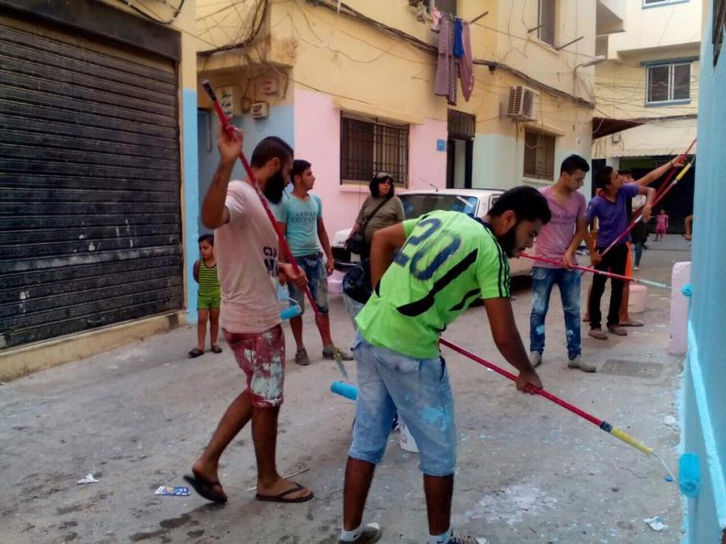
- 10activities were implemented by youth committees as wall painting, participating in demonstration in occasion of Labor’s Day, organizing activities in reviving memory of Nahr el Bared crisis as march ins, Marathon “running for right to work”, dissemination and publication of campaign’s studies, presenting film entitled ‘300 night’ in addition to documenting and filming interviews on right to work topic.
- One central demonstration in the Labor Day in Beirut with participation of 1246 beneficiaries.
- Six demonstrations were conducted in Day of Solidarity with Palestinians with Participation of 925 beneficiaries in all areas.
Public awareness is raised, and systematic campaigning and lobbying carried out, about the need to abolish discriminatory laws, procedures and practices against Palestinian refugees in Lebanon, especially with regard to Right to Work (RTW)
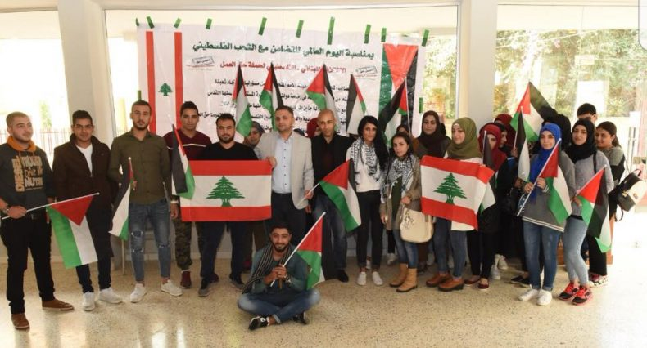
Then, to enhance the campaign's objectives and to facilitate mobilization and discussions around Palestinian rights, feed the right to work social media with all the campaign activities, articles written by other newspapers about right to work for Palestinian refugees, case studies and media outreach mobilize Lebanese and Palestinian communities to participate in the campaign’s activities.204 visitors to the campaign page per day, 52,113 followers to the campaign page on Facebook, and 791 on Twitter, and 113 People are interacting with our publications on social media through sharing and liking and commenting.

Moreover, and to provide more effectiveness to the campaign, creation and maintaining function Pal-Leb shadow committees. A coalition of Palestinian and Lebanese organization is already formedconsisting of 108 members (73 organization and 35 activists), that meet monthly in each area (24 member in Beirut, 26 in Saida, 19 in Tripoli,Beqaa 21 and 18 in Tyre) to discuss the upcoming activities, suggesting activities and plans, help in mobilization and in the lobby meetings. During the reported period, 50 meeting were held by the coalition.
Another committees which is Palestinian Lebanese youth committees 74 youths, where they play an important role in the campaign, some of their activities: feeding back the campaign by case studies, activities, creation of youth activities, make the interactive theaters where they are act in these theaters, and wall painting to reflect the violation they are facing in the labour market, help us making the seminars inside their universities, high schools and vocational training centers. During the reporting period, 39 meetings were conducted by the youths with coordination of field coordinators to discuss different topics and activities.
The right to work campaign demonstrates increased capacity to promote and advocate for social-economic right for Palestinian refugees in Lebanon.
- 17 lobbying actions targeting prime ministers, stakeholders, mayors of municipalities, embassies and figures from Lebanese political parties. The main visit was conducted to President of Lebanon Government Michelle Aoun to discuss the issue of right to work for Palestinians. The president had emphasized that the Ministry of Labor shall expedite the adoption of executive decrees to facilitate the entry of Palestinian refugee into the normal, administrative and vocational labour market and to grant them the right to benefit fully from social security contributions.
- A round table was organized about the achievements and strategic of right to work campaign with participation of syndicates, municipalities, Palestinian Factions and Lebanese parties, UNRWA camp Director and representative from popular committees.
- One interactive theatre was done about right to work for 70 attendees.
- Nahr el Bared advocacy Committee which is led by Najdeh had met four times discussing the reconstruction progress of Nahr el Bared camp and reducing of services and budget of UNRWA. Basing on that, demonstrations and sit- in were organized to lobby for continuing the reconstruction of Nahr el Bared camp, protest against the cuts of UNRWA’s budget which is leading to reduce of its services, and refusing and protesting against the declaration of Jerusalem as Capital of Israel. Also, 6 raising awareness sessions were conducted to local community informing them about consequences of UNRWA’s budget cut
- The property right campaign’s members discussed the impact of Lebanese new law regarding renting houses on Palestinian refugees and their rights, and action plan was initiated to raise the awareness of Palestinians about the new law.
- Activities with coordination of Right to return Coalition were implemented in Nov advocating for right to return in event of Balfour Declaration
- Right of Return Coalition had met to discuss the coalition’s situation and activities at local and international levels.
Direct and Indirect beneficiaries:
- Palestinian and Lebanese workers, employees, unions and syndicates, embassies
- Lebanese and Palestinian youth and communities
- National, local, and international decision-makers, donors, and stakeholders.
Total | M | F | Activity
452 | 126 | 347 | Workshops
93 | 59 | 46 | Seminars
28 | 15 | 13 | Round tables
835 | 385 | 450 | Youth activities
70 | 40 | 30 | Interactive theater
2351 | 1121 | 1230 | demonstrations
3862 | 1746 | 2116 | Total

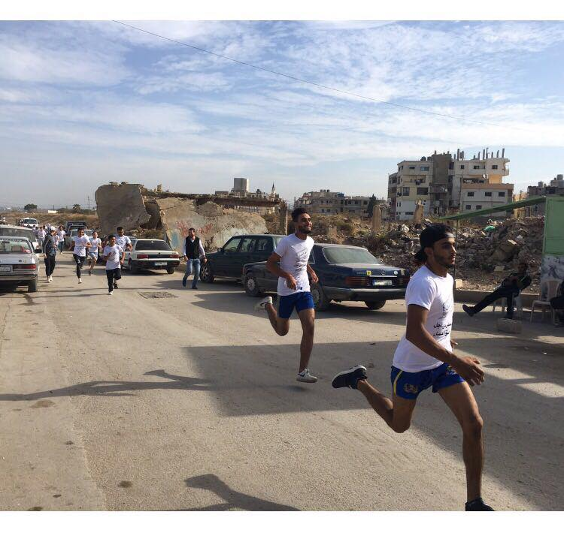
Challenges
- Not mentioning anything regarding the rights of Palestinian refugees in Lebanon in the ministerial statement of the current government.
- The continuation of the racism and stereotyping against the Palestinian refugees from the ministers and people, that makes the possibility of violating the campaign from the Lebanese parties to gain support.
- The Syrian crisis and its repercussions on Lebanon in general and redefining priorities of the government to deal with refugees from Syria and the crisis effects.
- The security situation in Lebanon in general and in some camps in particular
- Arbitrary arrests at the entrances to camps for Palestinians fleeing war in Syria

Women’s Social and Economical Empowerment Program:
2nd strategic objective: To endow Palestinian refugee women in Lebanon with skills to enter the labor market and to contribute economically
3rd strategic objective: To develop the capacities of Palestinian women in camps and gatherings to participate in planning, evaluation and decision making

Brief updateThe recent VT changes the plan towards having short and fast courses, ranged between 2 to 6 months (hairdressing, skin care, Photoshop, advertisement, chocolate decoration…) basing on the labor market’s needs, recommendations and requirements.
In 2017, 41% of graduates had found jobs opportunities; of them 19% are divorced and married women who are the main breadwinner for their families. Besides, 27 graduates had started to run their own business after receiving tools upon their graduation within projects which are funded by Danchurch Aid and ANERA. Eighteen graduates had run their business at their own expenses and started to generate income.
Target groups

The vocational training section had received a total of 465 direct beneficiaries to acquire them professional skills and enhance their social and economic opportunities as well, of whom 82% are 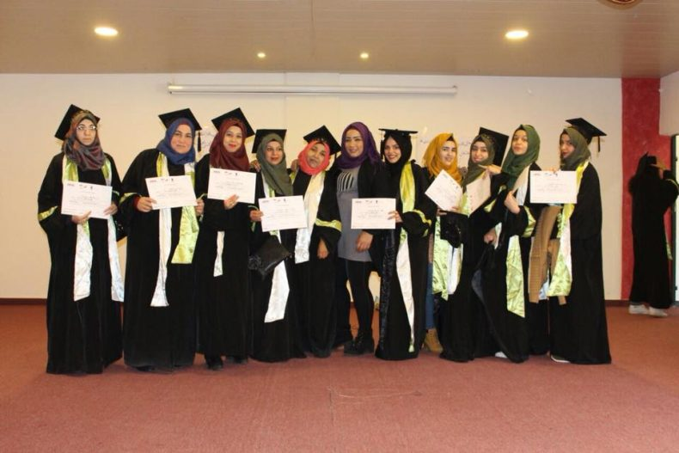females, 78% Palestinians, 11% Lebanese, 10% Syrian. In addition, the VT program targeted 545 indirect and direct beneficiaries (80% females) by involving them in courses, career orientation and awareness raising workshops.
The following table shows the number of beneficiaries and graduates who received vocational training, and those who secured their jobs in 2017:

Number of beneficiaries who receive Vocational Training Jan- Dec 2017

PRL | PRS | Lebanese | Syrian |  | Female |  | Male |  |  | Total
239 | 124 | 53 | 48 |  | 381 |  | 84 |  |  | 465
Number of Graduates Jan- Dec 2017
* Note: the number of graduates are more than beneficiaries mentioned above because some courses were started at end of 2016 and ended on 2017

PRL | PRS | Lebanese | Syrian |  | Female |  | Male |  |  | Total
319 | 129 | 64 | 59 |  | 483 |  | 89 |  |  | 572
Number of beneficiaries who receive career orientation and awareness training Jan-Dec 2017

Indirect beneficiaries |  | Direct beneficiaries |  |  | Total
Female | Male | Female | Male |  | Female |  |  |  | Male
457 | 88 | 546 | 110 |  | 1003 |  |  |  | 198
Graduates securing employment after receiving training Jan-Dec 2017

PRL | PRS | Lebanese | Syrian | Other |  | Female |  | Male |  |  | Total
142 | 37 | 32 | 21 | 2 |  | 190 |  | 44 |  |  | 234
Outcomes | Indicators | Implmented activities
Palestinian refugee women are equipped with marketable vocational skills | 465 beneficiaries, of whom 82% are females, have received vocational training skills.  234 (at 41% of total graduates) have improved their self-confidence by obtaining jobs and improved the socio-economic situation | - 31 vocational training courses were conducted.  - 395 visits to job market and companies were conducted for securing on the job training for 337 VT beneficiaries and job opportunities for 234 graduates. 44 new employers were targeted in this year.  - 38 meetings for graduate committees and 58 for beneficiaries committees were conducted to discuss issues related to VT courses, job opportunities, trainings, and activities  - Meetings for VT instructors were organized on monthly bases for following up the implementation of the VT plan and job training and job placement for graduates.
Empower the Palestinian refugee women to practice their economic rights | 656 VT graduates and beneficiaries have acquired knowledge on social, psychological, employability and rights issues  545 parents, students and community members are better aware of psychological, employability and rights issues | - 83 career counseling workshops were conducted with the attendance of 877direct and in direct beneficiaries, 706 were females  - 92 raising awareness workshops were conducted with participation of 498 VT graduates and beneficiaries and 320 parents, students and community members.

Challenges:

The main challenge at the programs’ level was to implement the plans despite of the instability in Lebanon conditions at the social, economic and political levels. Also, a major challenge was faced by the Vocational Training section, which is the insufficiency in the funding for the procurement of equipment for the courses to be responding to the need with high tech and quality as well. Thus, these changes were:
- Increasing the number of graduates who secured jobs while unemployment rates are high and deterioration of socio-economic situation of Palestinian refugees.
- Increasing the number of targeted employers while Palestinian refugees are denied from their legal and human rights in Lebanon.

Case study:
Meza M. I
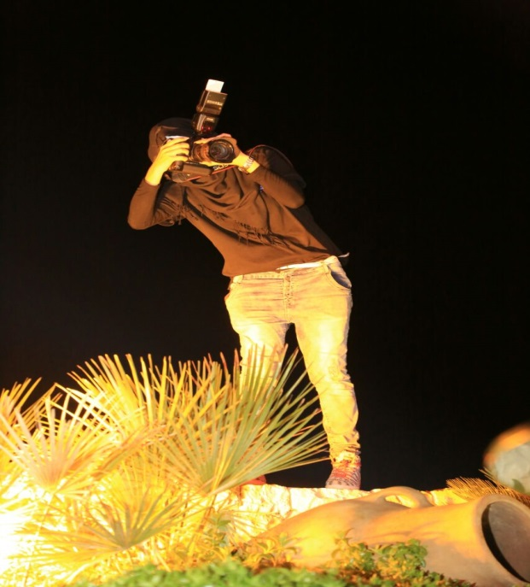
A 22 years old Palestinian refugee lives in Beddawi camp,
She was always dreaming that one day she will be a successful photography, and she was always filling her hobby by using her mobile phone to take pictures. When a friend of her saw her pictures that she is posting on her Facebook page, she advised her to develop her hobby and to be a professional photography by seeking for a vocational training center that can help her in enhancing and developing her skills.
Meza said “when I knew that AN will start a course in photography, directly I went there and register my name, when I started I was very happy that all what I was seeking for find it here in the center, I do my best to be the first one in the class, I didn’t lose any chance that could allow me acquire a new knowledge, I even start accompany the trainer in covering the events (weddings, celebrations, outdoor photo sessions ….)
When Miza finished the course, she volunteered in one of the famous studios in Tripoli, and there she started building up her capacity and making relations with people. Miza said “one of my favorite gifts that I got is a camera that I received from my father, when I got it, that was as a dream has been achieved for me. After that I started taking photos and working at night to do the photo shop for the pictures”
“Now I have my Facebook page that I post all the pictures that I took, and to let people introduce my work, I’m very glad that I had likes, positive comments and shares to my pictures and a lot of my friends and relatives call me to cover their events or to take photos for them, and that’s help me a lot in saving some money cause I’m preparing to open my own studio”
“I’m very gratitude for AN open the door for me, and helped me, as a woman, to have her own profession and to be active member in her society and her family”.

Women’s Right Program:
Brief update
New approaches by Women’s Right Program:
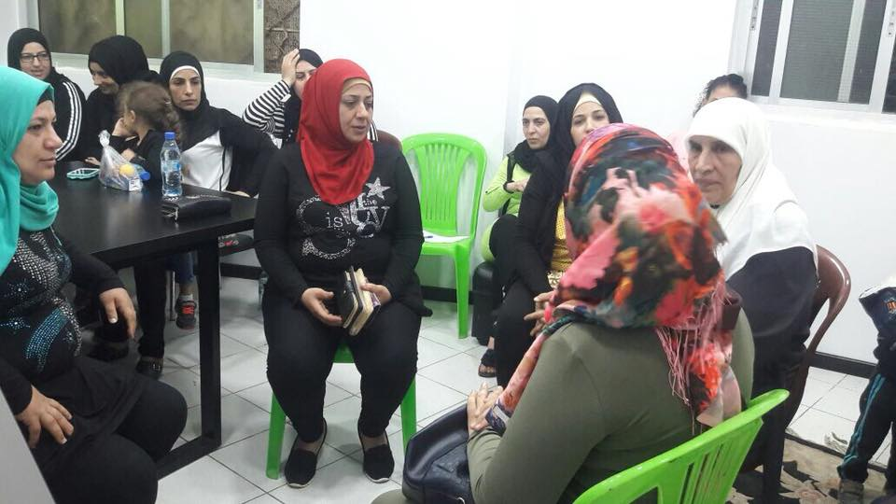
In 2017, Women’s Rights program is working towards creating women committees in Palestinian camps of Lebanon where its aim is to mobilize local community advocating for gender equality. Those women members are considered as leaders in the local community. Consequently, seven women committees of 52 members were formed in Burj el Barajneh, Shatila, Beddawi, Nahr el Bared, Sidon, Tyre and Beqaa to start prepare for activities contributed to eliminate violence against women in local communities. The women are trained on different topics as leadership, communication to be empowered and acquired different skills that help them in advocating. Shatila and Burj el Barajneh women committees had had started their own income generating project after got trained and supported.
Najdeh implements masculine Project. Masculine program is a program widely used throughout the world (in more than 22 countries) to end violence against women and girls. The program targets young men and youth aged between 14 to 24 and living in refugee and marginalized communities. The program is given a rate of 12 sessions that include drama, games and discussions that promote critical individual and collective thinking, address how individuals of both sexes can benefit from addressing gender stereotypes, question their existing positions, and create new paths towards gender equality. Six groups of men were formed with participation of 97 men and each group will attend around 10 sessions with psychologists. These sessions contribute to reduce the impact of inherited social concepts, interaction and psychological and social problems by knowing how to deal with them, identify the concept of gender, identify the impact of domestic violence on the individual and society, social problems especially drugs and their impact and ways of dealing with them. The program also contributed to improving the psychological and intellectual situation towards having positive relationship among both gender.

4th strategic Objective: To strengthen the protection capacity and resilience of vulnerable groups especially women

Outcome 1.1: Ten per cent of GBV survivors are empowered psychologically, socially and economically
Indicators:
- 416 GBV survivors (72% females and 28% males) receive support services
- 141 women and girls involve in support group therapy
Activities:
- At total of 416 survivors out of them (117 males & 299 Females), and (212 PRL, 59 LB, 81 PRS, and 63 are SYR, and one other), were provided with different types of counselling services by NAJDEH counsellors, based on their needs. Of the total number of survivors, 30% were subjected to physical violence, 3% were subjected to sexual harassment, 5% suffered from severe economic conditions and depression due to gender inequality and discrimination. All 416 survivors who subjected to violence, suffered from emotional and psychological problems. In addition, of the total number of the survivors, 7 cases were referred and received legal assistance whereas 4 of them had reached a solution. 189 cases of the total number of survivors have referred to psychologists and have received individual psychological consultation where 110 survivors had reached a solution, and 20 cases had received social intervention (five of them reached a solution, and 56 cases had debriefing sessions.
- 11 therapy supporting groups were formed with participation of 141 women survivors; girls and boys ( 6 groups were formed to exchange experiences for debriefing purposes and 5 groups for expressing beneficiaries themselves and receive psychosocial orientations)
- The referral to counseling center was as follows: 33% of survivors are from Najdeh’s program beneficiaries, 21% are from local communities, 7% through raising awareness sessions, 22% are cases approach counseling center and 17% are referred by other organizations.

Outcome 1.2: Increased community knowledge among women and men on combating GBV and VAW and on women’s rights
Indicators:
- 1100 beneficiaries (80% and 20% males) improve knowledge on GBV, rights and discrimination
- 1632 beneficiaries from schools, local NGOs and local Community (81% and 19% males) increase knowledge on related social and psychosocial issues
Activities:

1- 41 community awareness groups were formed with the participation of 1100 beneficiaries. Of the total number of beneficiaries, 876 are females at 80% and 224 are males at 20%, and (62% PRL, 7% LB, 17% PRS, and 14% SYR). The 41 groups were distributed over gender as follows: 13 females groups and 4 males group, 11 local NGOs beneficiaries, 7 local groups, and 6 mixed groups (males & females).
2- 191 raising awareness workshops were conducted during the reporting period. Topics tackled in the workshops focused on following:
- 41 workshops about violence.
- 40 workshops about discrimination.
- 36 workshops about human and women rights.
- 40 workshops on social and psychological topics
- 34 workshops about life skills.

3- 62 educational awareness-raising workshops were conducted during the reporting period with the participation of 1632 persons from schools, local NGOs and local community. Of the total number of participants; (1316 are females, and 316 are males)). The participants attended the following workshops: GBV, life skills, sexual harassment and other topics related to community needs such as; psychological health, time management, anger management, pressure management communication skills, women’s role and participation, harassment, violence, gender, children’s problems and their management, Drugs, CEDAW, early marriage, protection mechanisms,etc. .

Outcome 1.3:Strengthened protection mechanisms among CSOS and NGOs

Indicators:
A majority of CSOs and NGOs agree to cooperate regularly and complement services

Activities:
- Establish a protection community network for women in Beddawi camp after meeting with nine local NGOs, which will be activated in 2018.

Fifth strategic objective:To strengthen Palestinian refugee women’s public and political participation

Outcome 2.1: Strengthened leadership, political participation and advocacy knowledge & skills among women civil society actors

Indicators:
- 80 female NGO workers and activists in Palestinian communities successfully complete knowledge and skills building activities
- 11 women members of Palestinian popular committees in Beirut, Beqaa and Tripoli gain in-depth knowledge on women’s rights, advocacy and campaigning.
Activities:
- Four training workshops were conducted for 80 women and girls who are working in 31 local NGOs and activists in local community. These trainings were held in Ein el Helwi, Rashdieh, Nahr el Bared and Wavel Palestinian camps. As a result, the following recommendations will be included in plan 2018:

- Targeting women in political parties and factions, in addition to the popular committees.
- Involving youth and men in these workshops.
- Diversifying of topics and techniques used, such as focusing on leadership, presenting successful case studies, using interactive methods and providing practical options.
- Training workshop was conducted to 11 women members in popular committees on topics of leadership where challenges were detected in their works:
- Appointment of meetings at late hours.
- Not listening to women's opinions and taking them in consideration in meetings.
- Not putting women's issues on the agenda.
- Lack of family support for women, which hinders their participation.
- Masculine mentality and social legacies that perpetuate discrimination between men and women.
- Formal image of women is limited to health and social committees.
- Lack of sufficient determination in women themselves to prove their existence.
- Marginalization of women's role in political meetings.

Outcome 2.2: Strengthened popular committee and political party responsiveness to women’s political participation
Indicators
Around three popular committees and two political parties agree to elaborate a joint action plan to improve women’s political participation
Activities:
- Coordination with popular committee in Mar Elias and meeting with the committee to put joint plan about activities where a group of forty women was formed and received 5 raising awareness sessions.
- Five interactive theaters were implemented with participation of 325 participants (256 females and 69 males) on topic of women’s participation in public and political life

Sixth strategic objective:To reduce gender based violence and gender discrimination against Palestinian women in Lebanon

Outcome 3.1:Increasing numbers of women and men community members and organizations are committed to defending women’s rights and combating GBV
Indicators
Growing rates of community members attend advocacy activities
Activities:
- The theme for 16-days campaign was about women’s participation in the political life, and it was from 19 Nov to 5 Dec 2017. 1156 participants (739 females and 417 males) had involved in different activities.
- 6 men groups had formed with participation of 95 men whose age over 30 years old discussing topic of women’s participation in the political and public life.
- Activities were implemented in occasion of Women’s Day with participation of 2029 beneficiaries from local community to advocate for Women’s Rights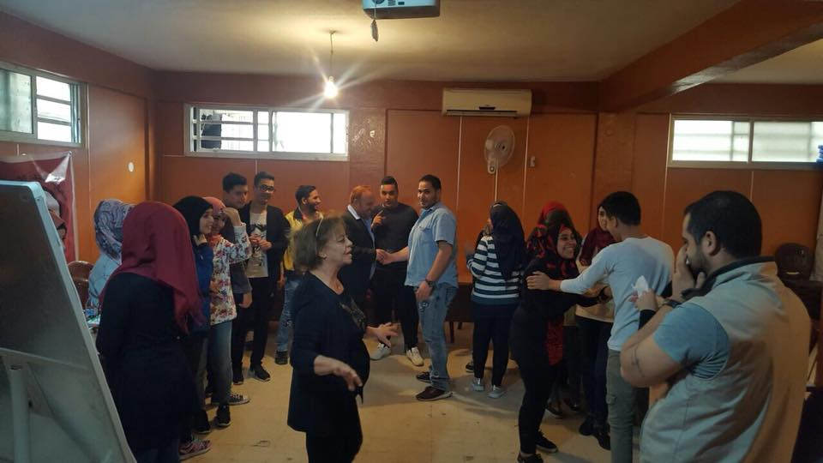
Outcome 3.2: Support for the civil and human rights of Palestinian refugee women in Lebanon and the equal rights of women in Arab countries is coordinated and strengthened at the national, regional and international levels
Indicators
11 local NGOs and networks adopted common agendas and action plans basing on CEDAW second shadow report
Activities:
- Palestinian Women’s Forum had met to discuss issues related to Women’s Rights and socio economic situation in Palestinian Camps and paper prepared about approaches and mechanisms of interventions.
- Six sessions were conducted with Palestinian Women’s Forum to present results of CEDAW second Shadow report for 199 participants (160 females and 39 males) from Palestinian factions and parties, popular committees, stakeholders and local communities working in Palestinian and Lebanese communities.
- 52 raising awareness workshops and 18 public sessions were conducted to 314 beneficiaries (249 females and 65 males) from 11 local NGOs on different awareness topics as violence, discrimination etc.
Lessons learned:
- Target schools and youth centers, and include youth meetings as part of the plan.
- Continue work in Masculine program to involve young men
- Share the experience of income generating projectsof women committeeswith beneficiaries.
- Targetother camps and gatherings (Mar Elias - Tyre gatherings).
- The importance of diversification the provision of information through creating new techniques and interactive exercises
- The importance of joint meetings among specialists and psychologists to exchange experiences
- The importance of staff care activities.
- The importance of producing and disseminating information materials on the program and topics of violence, discrimination and rights.
Issues to work on:
- Reach the participation ofmales in awareness groups at rate of 30%
- Training on the subject of rights to the staff in depth.
- Coordination and cooperation and existence of clear system and mechanism for referring and support among local NGOs especially providers of services for women and children to achieve integration of service.
- Forming protection networks for women and children and create codes of conduct,its mechanisms and procedures for networks.

Mother and Child Program:
Seventh strategic objective: To develop the cognitive, physical linguistic and social abilities and skills of children aged 3-5 years
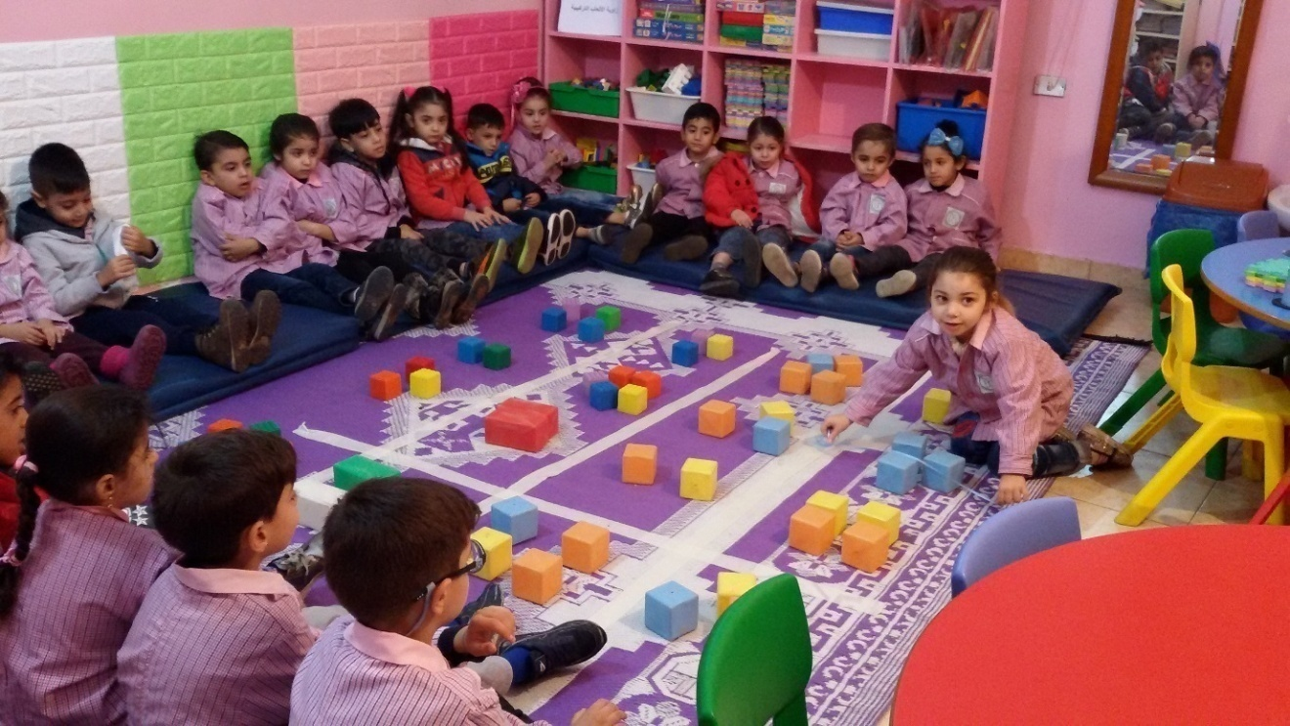

Update: the program had focused in building the staff’s capacity with the European Foundation for Development and Integration on topics related to Integrative education, student and teacher, Writing problems and attention and concentration. Besides, the staff trained on developmental characteristics of childhood up to 6 years / within Welfare Association Program: Eight teachers had graduated from Saint Jesuit University and received trainings on classroom management - Access to mathematics, design lessons and assessment, etc.
The Storytelling and reading project is targeting parents and children which aims to develop reading skills for parents, giving children a chance to sit with their parents to listen and have dialogue with them, the child learn through the story: Societies - Language - Mathematics - Identify the best in social life. Staff has worked with parents to develop the concept of story to be more serious in follow-up of their children. Najdeh had worked to develop the role of animators to follow-up the children in the kindergartens and give the child a chance to tell the story in front of children
Targets of the program:
Beneficiaries of Mother & Child:
- 429 children (210 female, 219 male) aged of 3-5 years old directly benefited from the holistic active learning programme at 6 KG. Of these, 51% are males and 49% are females. The overwhelming majority of children are Palestinian from Lebanon 61%, 22 % Palestinian from Syria, 4% are from Lebanese families and 12% belongs to Syrian families.
- Indirect beneficiaries, 305 families (256 mothers and 49 fathers).
The 429 children belong to 382 families with overwhelming majority, at 54%, of family socio-economic status is hard where they earn the minimum and below the minimum monthly income of living.
Outcomes | Indicators | Implemented Activites
Children aged 3-5 are enabled to integrate in primary school | 30% of children completing AN KG Level three are enrolled in UNRWA schools and display very good to excellent performance levels for scholastic year 2016-2017 | - Pre-school environment has been enriched through physical improvements and dissemination of progressive and secular teaching/learning resources and approaches  -429 Palestinian refugee children aged between 3-5 years old (49% girls) have received quality pre-school education in a creative and secular learning environment as follows: 129 in 3 years age group, 149 in 4 years age group and 151 in the 5 years age group, and are well equipped to enter the UNRWA primary schools  - Staff has improved the situation of 130 children who suffers from different problem (36% of children language, 28% of them physical problems, 62% from mental problems, 28% suffer from social problems and 6 are disabled children.)
Parents are empowered to assume a bigger role in the educational and social development of young children | 70% of parents gained knowledge on Active Learning, the Rights of the Child and Child Protection | - 34 meetings had conducted to tackle social, educational, and health topics with participation of 319 mothers and 22 fathers, 26 women from surroundings  - 779 visits were conducted to parents to follow up children’s educational progress and their problems.  - 355 activates had conducted and attended by 256 mothers and 49 fathers have increased their awareness of the active and secular learning methodology, the importance of kindergarten for children, child psychology, child rights, abuse and protection.

Case study- Shatila KG
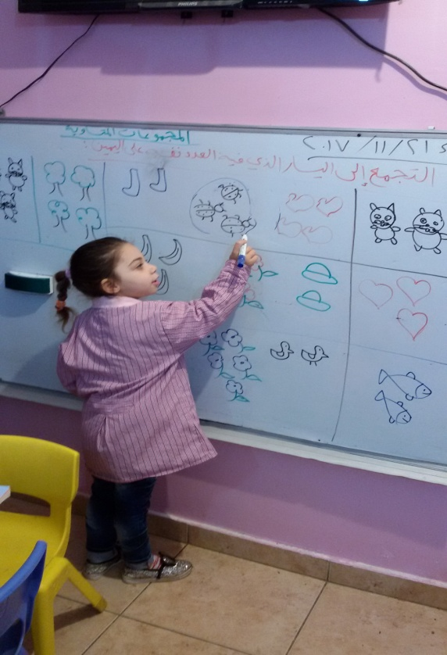
Name: Rahaf Akram Ahmed
Age: 5 years
Number of family members: 8, Rahaf is the youngest
Rahaf is a loving girl who loves kindergarten and her friends and likes to play with them and she is committed to the full time and wants to participate in collective action
She suffer problem in concentration and hyperactivity and she is unable to apprehend the instructions of the animator like her peers.
During the follow-up since last academic year, the child suffers from learning difficulties but the specialist did not follow her.
An intervention plan was developed by the Center Committee, which includes helping the animators with tasks, encouraging, and reinforcing the child, draw and color in large areas.
Implementing exercises for the development of small muscles such as playing with clay, holds a sponge ball, and tears the papers, etc. These activities helped to develop the abilities and improve the performance of the child with the help of animator. The animator started to adapt the exercises to suit the child's abilities.
The child was detected on activities of having motor hyperactivity, and the animators started to assign tasks for her as arranging games and reading and writing.
The intervention plan had left its positive results on the child in terms of changing her violent behavior and started to respond to the instruction of the animator. The child had shown a slow improvement in her educational achievement and she was rewarded in each activity. The follow up and implementation of the plan is continuing.

Psychosocial and Educational Support Program:
Eighth strategic objective: To strengthen the psychological, social, educational and learning abilities of children, adolescents and youths of both genders aged 6-24
Update about program: Association Najdeh had initiated the formation of Child Protection Committee with Asmae in Tyre with coordination of local and INGOs working in the Palestinian communities. After this successful community initiative, the experience started to replicated in other Palestinian communities in Burj el-shemali camp, the CPN included 12 local and INGO,
10 members in Ein el-Helweh, 25 members in Burj el Barajneh and 7 members in Beddawi camp. Different raising awareness activities are implemented for parents, local community, stakeholders about child rights; even the NGOs are getting trainings on different topics as case management, community initiatives are conducted, activities in different occasion are implemented. These networks had set its code of conduct and regulations, and the lead of CPN is rotated among NGO’s members by election.

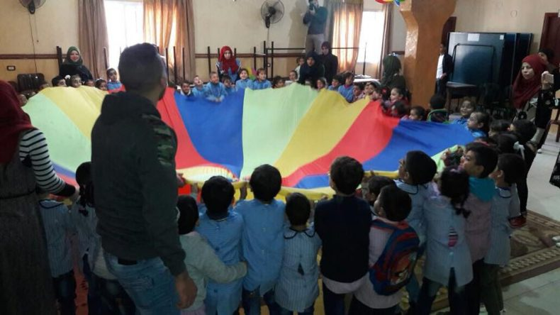
Association Najdeh is still working with children in identity and leadership topic in partnership with Christian Aid. Thechildren did their researches; they approached local NGOs, stakeholders, popular committees, etc. Also, group of children who are considered as leaders were trained to train their peers. children have acquired knowledge on rights linked to their daily and community life, they also have introduced and trained on some skills that enabling them to play leading advocacy role in the future on issues related to their and to community rights.
Since couple of years, Najdeh is working with children adopting different themes, techniques and approaches as S-he deals, I- deal, little deal, citadel of safety, etc. under the frame of child protection.

Achievements of the Program:

Outcome 1: Children and youth at risk and GBV survivors are enabled to overcome psychosocial and behavioral problems

Indicators:

- 2883children benefit from PSS activities and 50% of them show progress in improvement at behavioural, psychological and social levels.
- 80% of children participate in support and debrief activities
- 70% of children acquire skills and knowledge to protect themselves from exploitation
- 80% of girls gained self confidence

Implemented activities:

- Forming of 331 PSS groups of 6753 children (55% females and 45% males)
- 146 support therapy sessions were implemented to 1146 children (264 females and 338 males) who suffer from social, behavioural, and psychological problems.
- 733 children cases (340 females and 393 males) were detected suffering from social, behavioural, psychological, educational problems and referred to social workers for receiving intervention.
- 309 cases from children were referred to psychologists and social workers to receive 832 individual therapy sessions. 288 cases show improvements.
- 146 raising awareness workshops and 185 protection activities were implemented
- 7934 daily, entertainment, educational, and awareness activities were conducted to 6753 children.
- Summer activities were implemented for 3 weeks with participation of 2100 children.

Outcome 2:Improvement of the educational levels of 1030 children and youth at risk

Indicators:

-70% successfully complete the formal school year education
- 65% are able to read and write
- 60% acquire recreational skills
- 70% are able to analyze, participate, and depend on themselves

Implemented activities:

- 3 groups of literacy classes were formed with 35 beneficiaries (67% females and 23% males)
- 24 tutorial classes groups were formed with 550 students (57% females and 43% males)
- 246 beneficiaries (157 females and 89 males) had benefited from library services.
- 2785 books and stories were borrowed from the library by 425 beneficiaries and 820 children had benefited from internet services in the library

Outcome 3:Children and youth at risk improve their cognitive and social abilities

Indicators:

- 60% gain creative skills
- 1200 beneficiaries attend workshops
- 50% of families acquire knowledge on exploitation of children and children’s rights

Implemented activities:

- 249 workshops were conducted to 2359 participants (1185 females and 51 males) about social, mental health, psychological, heath, life skills, parenting problems, etc
- 33 support groups were formed with participation of 680 women and girls in 134 sessions
- 7 psychodrama groups were formed with participation of 106 women and girls in 15 sessions.
- 808 interactive activities were implemented with participation of children and their parents to promote communication
- 180 women were referred to psychologists to receive 480 individual sessions
- 340 individual therapy sessions were conducted to 88 children (44 suffer from emotional violence, 8 from physical violence, 30 neglect and 6 exploitation)
- 1040 visits were conducted to 1002 beneficiaries for follow up purposes.

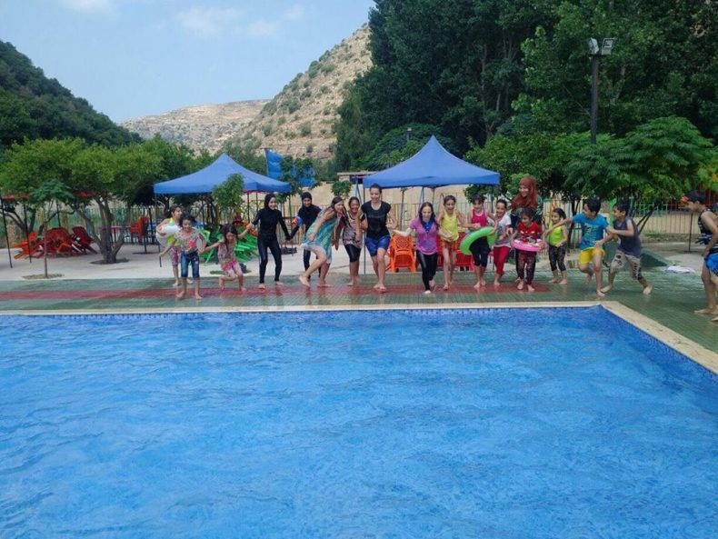

Target Groups:
Component | Female | Males | PRL | Lebanese | PRS | Syrian | Total
PSS groups | 3706 | 3047 | 2474 | 270 | 1209 | 2800 | 6753
Literacy groups | 31 | 4 | 19 | 7 | 2 | 7 | 35
Tutorial classes | 343 | 262 | 313 | 28 | 173 | 92 | 606
Library | 157 | 89 | 211 | 0 | 35 | 0 | 246

Lesson learnt:
- The various techniques and methods of work used with the parents, children and local community and with the participation of the PRS beneficiaries resulted in building strong relationship with them, which helped in finding several solutions to their problems as well as helped in their integration with their new life.
- Exploring projects that respond to the community needs as well as convenient to the centers’ capacities and resources, especially in times of emergency.
- Securing safe environment for local and displaced children where they can live and integrate together.
- Formation of child protection policies and child protection committee in Palestinian camp with the participation of local and international organizations and decision makers to contribute to the finding certain ways of stopping violence and exploitation against children.
- Encouraging the children creativeness, especially in turn of art, folk dance, theater and singing, this helped in building up their personalities as well as their personal identities.
- Conducting certain topics in researches among children on health, personal IDs, this can create awareness among children of their rights and the rights of their community.
- Exploring new techniques with working with children as adopting as I-deal and Citadel of safety methodology, etc through involving staff in attending training on these new methodology to be more experienced.
- Association Najdeh had learned to trust the capabilities and abilities of children by giving them roles to lead and mange groups and activities, and even plan activities.
- Importance of having common and recreational activities with parents and children about identity and national themes.
- Importance of giving the lead for children to be active members in the local communities.
- Importance of having children initiatives to plan for activities and implement them by their own.
- Najdeh had encouraged the children to do researches by their own about their rights to enrich their knowledge and stimulate their thinking.

Social Affairs Program and Loans Program:

Ninth strategic objective: To improve the social and economic situation of the most marginalized Palestinian families in camps and communities in Lebanon

Outcomes | Indicators | Implemented Activites
Highly vulnerable Palestinian families are assisted to access educational, health, social support | 56 young women and men have pursued secondary/university education  2037 families received basic relief food and clothing items  20 chronically ill persons had access to appropriate health care  Children have secured their protection needs through financial sponsorship. | - 56 Palestinian refugees young students, categorized as hardship cases with the highest level of need received one-time educational grant & support.  - 2037 hardship case families benefited from in-kind assistance of basic services (food, clothes, hygiene)  - 20 chronically ill persons received financial assistance covering partially their health operations/medications.  - 35 vulnerable children were sponsered and consequently received their protection needs.
Highly vulnerable Palestinian families are enabled to become economically self-reliant | 243families have established income generating projects  27% female beneficiaries had received loans to improve their income generating project | - An amount of 580,500 USD was loaned to 243 beneficiaries (216 Palestinians, 46 Lebanese, and 2 others)  - 113 indirect beneficiaries are working in the income generating projects that were expanded because of the loans
Community solidarity networks with vulnerable groups are strengthened through local donations | 98,691,000LBP is collected annually from local wealthy individuals and institutions | An amount of 98,691,000LBP was collected by staff as solidarity activities from wealthy individuals and institutions and provided for the SHCs to support in improvement of the most vulnerable members of the local community as categorised by Najdeh staff.

Emergency Program:
Tenth strategic objective: To ensure immediate responsiveness to the needs of conflict-affected groups in Lebanon

Outcomes
- Vulnerable conflict-affected refugees and IDPs have benefitted from rapid access to protection services.
- The resilience of conflict-affected refugees/IDPs has been enhanced due to alternative assistance programs.

Indicators:
- 9 humanitarian projects were implemented in the different regions, mainly on protection, livelihood, resilience, winterization (fuel distribution), food, education.
- The humanitarian projects improved the living conditions of 7,705 families, consisting of 31,999 individuals, of whom 6,275 PRS, 314 PRL, 883 Syrians, 233 of other nationalities.
Activities:
- 9 different kinds of emergency projects targeting 6,275 PRS, 314 PRL, 883 Syrians, 233 of other nationalitiesbenefitted from the different kinds of relief distribution, cash for work projects, psychosocial support, protection, etc projects.
- Following up, monitoring and evaluating for the emergency projects were done at different levels

http://www.lpdc.gov.lb/DocumentFiles/%D8%B1%D8%A4%D9%8A%D8%A9%20%D9%85%D9%88%D8%AD%D8%AF%D8%A9%202-636365070915808725.pdf

